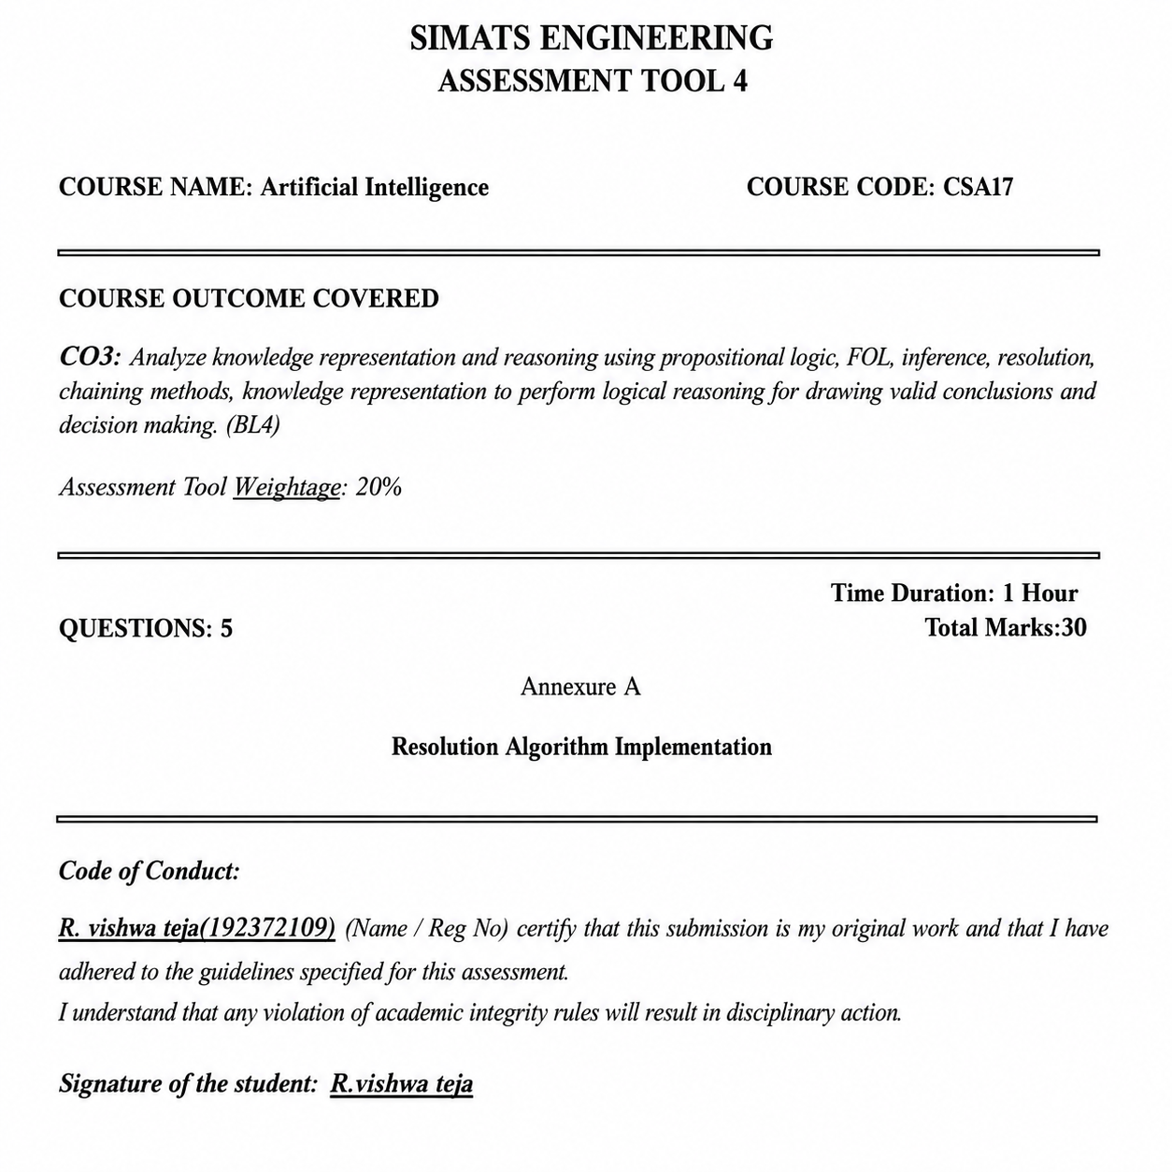

Resolution Algorithm – Assignment Answers
The following five problems are solved using propositional logic, CNF conversion, goal negation, resolution steps, and the empty clause (□), following the questions in the uploaded assessment.
Question 1 – Rain and Wet Ground
Knowledge Base
- If it rains, then the ground becomes wet.
- It is raining.
Goal
Prove that the ground is wet using the Resolution Algorithm.
1. Propositional Logic
Let R = It is raining. Let W = The ground is wet.
Rule: R → W
Fact: R Goal: W
2. CNF Conversion
R → W ≡ ¬R ∨ W
CNF Clauses:
- C1: ¬R ∨ W
- C2: R
3. Negate the Goal
Negated goal: ¬W
4. Resolution Steps
Resolve C1 (¬R ∨ W) with C2 (R):
Result: W
Now resolve W with the negated goal ¬W:
W ¬W
\ /
□
Empty clause □ is obtained.
Final Conclusion
The goal W (the ground is wet) is proved by Resolution.
Question 2 – Student Assignment Submission
Knowledge Base
- If a student submits the assignment, then the student receives internal marks.
- Rahul submitted the assignment.
Goal
Prove that Rahul receives internal marks using the Resolution Algorithm.
1. Propositional Logic
Let S = Rahul submitted the assignment. Let M = Rahul receives internal marks.
Rule: S → M
Fact: S
Goal: M
2. CNF Clauses
- C1: ¬S ∨ M
- C2: S
3. Negate the Goal
Negated goal: ¬M
4. Resolution Steps
Resolve C1 (¬S ∨ M) with C2 (S):
Result: M
M ¬M
\ /
□
The derived M and the negated goal ¬M produce the empty clause □.
Final Conclusion
Rahul receives internal marks is proved by Resolution.

Question 3 – Library Membership
Knowledge Base
- If a person is a library member, then the person can borrow books.
- Priya is a library member.
Goal
Prove that Priya can borrow books using the Resolution Algorithm.
1. Propositional Logic
Let L = Priya is a library member. Let B = Priya can borrow books.
Rule: L → B
Fact: L
Goal: B
2. CNF Clauses
- C1: ¬L ∨ B
- C2: L
3. Negate the Goal
Negated goal: ¬B
4. Resolution
Resolve C1 (¬L ∨ B) with C2 (L):
Result: B
Now resolve B with ¬B:
B ¬B
\ /
□
No contradiction remains after removing the negated goal; the empty clause proves the goal.
Final Conclusion
Priya can borrow books is proved using Resolution.

Question 4 – Placement Eligibility
Knowledge Base
- If a student clears the aptitude test, then the student is eligible for placement.
- Arun cleared the aptitude test.
Goal
Prove that Arun is eligible for placement using the Resolution Algorithm.
1. Propositional Logic
Let A = Arun cleared the aptitude test. Let E = Arun is eligible for placement.
Rule: A → E
Fact: A Goal: E
2. CNF Clauses
- C1: ¬A ∨ E
- C2: A
3. Negate the Goal
Negated goal: ¬E
4. Resolution Steps
Resolve C1 (¬A ∨ E) with C2 (A):
Result: E
Resolve E with ¬E:
E ¬E
\ /
□
5. Resolution Tree
¬A ∨ E A
\ /
E
|
¬E
|
□
Final Conclusion
Arun is eligible for placement. The empty clause □ confirms that the goal is proved.
Question 5 – Access Control System
Knowledge Base
- If a user enters the correct password, then the user is authenticated.
- If a user is authenticated, then the user is granted access.
- The user entered the correct password.
Goal
Prove that the user is granted access using the Resolution Algorithm.
1. Propositional Logic
Let P = User entered the correct password.
Let A = User is authenticated.
Let G = User is granted access.
Rules: P → A; A → G
Fact: P
Goal: G
2. CNF Conversion
- C1: ¬P ∨ A
- C2: ¬A ∨ G
- C3: P
3. Negate the Goal
Negated goal: ¬G
4. Resolution Steps
Step 1: Resolve C1 (¬P ∨ A) with C3 (P).
Result: A
Step 2: Resolve C2 (¬A ∨ G) with A.
Result: G
Step 3: Resolve G with the negated goal ¬G.
G ¬G
\ /
□
The empty clause □ is obtained.
5. Resolution Chain
P
|
+----> A
|
+----> G
|
¬G
|
□
Final Conclusion
The user is granted access. The Resolution Algorithm derives the empty clause □, so the goal is proved.

FINAL ANSWERS SUMMARY
Question | Conclusion
Q1 – Rain and Wet Ground | Ground is wet – PROVED
Q2 – Student Assignment | Rahul receives internal marks – PROVED
Q3 – Library Membership | Priya can borrow books – PROVED
Q4 – Placement Eligibility | Arun is eligible for placement – PROVED
Q5 – Access Control | User is granted access – PROVED

